|  |  |
| --- | --- |
| C:\Users\ccomputer\Desktop\aalogo1.jpg | **Alumni Association**  **of**  **Government College of Engineering, Aurangabad**  **(AAGECA)**  **c/o Govt. College of Engg. Aurangabad, Osmanpura, Station Road, Aurangabad- 431 005**  **Website:** [**www.gecaalumni.org**](http://www.gecaalumni.org) **Email:** [**gecaalumni555@gmail.com**](mailto:gecaalumni555@gmail.com) |

**Report for SAT activities conducted for year 2022-23**

The Annual Alumni Meet, a felicitation ceremony for the best outgoing student, the distribution of financial assistance scholarships, the Golden Jubilee celebration of the batch of 1973, a cultural program showcasing an award-winning play, and a dance workshop by an esteemed dance guru. Each event contributed uniquely to the college's mission of promoting academic excellence, alumni engagement, cultural enrichment, and student support.

On February 5, 2023, GECA hosted its Annual Alumni Meet, featuring the distinguished Mr. T. N. Munde from the 1985 batch of Civil Engineering. His presence inspired attendees, highlighting the impact of a GECA education. The event began with a warm welcome, followed by cultural dance performances, speeches, and stalls showcasing college projects. These activities facilitated interactions between alumni and current students. The meet concluded with a sumptuous dinner, underscoring the strong bonds and legacy of excellence at GECA.

On March 29, 2023, Miss Maheshwari Birajdar was honored as the best outgoing student for 2022-2023 at GECA. The ceremony, attended by faculty, staff, students, and guests, celebrated her academic journey. She received a gold medal and Rs. 51,000 cash prize from sponsor Shri M.B. Patney. In her speech, Miss Birajdar thanked her mentors, peers, and family, stressing the value of perseverance. The event highlighted the significance of acknowledging student achievements and inspiring others.

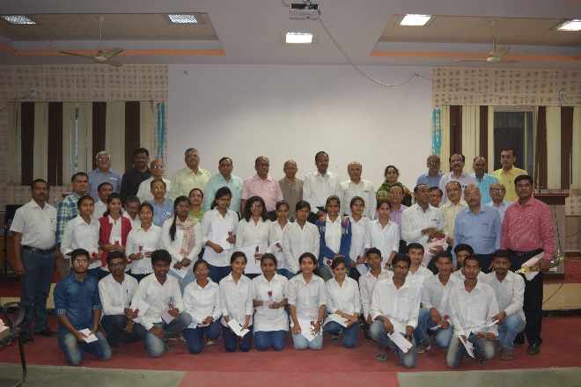 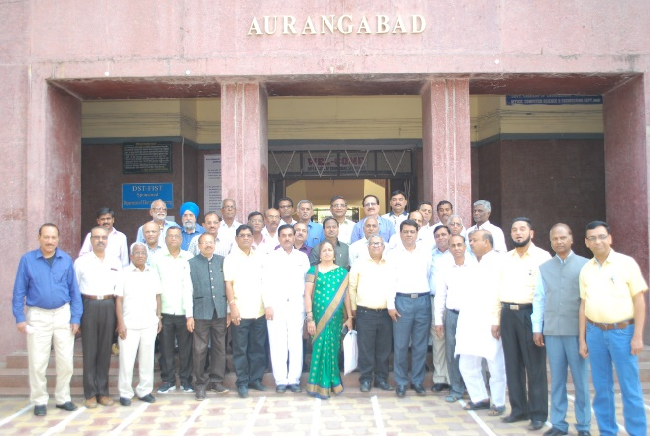

The GECA Alumni Association awarded financial assistance scholarships of Rs. 24,000 each to 27 deserving students, based on academic merit and financial need. This initiative reflects the association's dedication to supporting education and empowering future engineers. The ceremony, attended by association representatives, faculty members, and recipients, emphasized gratitude and community spirit. These scholarships not only provided financial aid but also symbolized GECA's commitment to fostering academic excellence and ensuring all students have the opportunity to succeed.

On April 8, 2023, GECA's Alumni Association organized the Golden Jubilee celebration for the batch of 1973 at the AAGECA office. The event reunited 26 esteemed alumni and faculty, fostering reflection on their academic journey and reinforcing the enduring bond between alumni and GECA. It highlighted the college's strong sense of community and shared achievements over fifty years.

On May 10, 2023, "Bhangad," the award-winning play, was presented at Sant Eknath Rang Mandir, Chhatrapati Sambhajinagar, sponsored by Ex. MLA Shri Shrikant Joshi. The cultural program included diverse performances like folk dances and music, showcasing Maharashtra's artistic talent. Joshi's sponsorship highlighted his dedication to promoting local arts and nurturing cultural heritage.

On August 22, 2023, Smt. Parvati Datta led a dance workshop at GECA focusing on Kathak and Odissi. Attended by 80 participants, the event explored dance's historical, cultural, and technical aspects. The workshop began with traditional rituals, emphasizing dance's spiritual essence. Smt. Parvati Datta engaged attendees with insightful presentations and practical demonstrations. Organizers Sharvari Dabir, Pratik Jangale, and Vaishnavi Kale ensured a conducive environment for learning, enhancing the workshop's educational value.